

Project Plan

“Media Bazaar”

Student| Student number:

I. B. | x

Tudor Rusu | x

E. P. | x

V. K. | x

Tutor:

Chung Kuah

FONTYS UNIVERSITY OF APPLIED SCIENCES

**HBO-ICT: English Stream**

March 2024

Table of Contents

INTRODUCTION 3

PROJECT STATEMENT 4

Formal Client 4

Current Situation 4

Project Goal 4

PROJECT OBJECTIVES 5

Project Approach 5

Project Deliverables and Non-Deliverables 5

Main features of the products 6

Project Constraints 6

Project Risks 7

PROJECT PHASING 8

Appendix A 9

# INTRODUCTION

Client hardware store chain “Media Bazaar” (daughter company of “Jupiter”) is hiring a team of software developers to implement the administrative system. The client communicates with the team via weekly meetings scheduled in advance by the team. The software team called “SystemTechies” consist of four members (E., I, Tudor, V.). The administrative system should aid in managing employee data and help regulate stock levels. The team was tasked to analyze the current situation and provide a working software solution to address all the issues.

# PROJECT STATEMENT

# 

## Formal Client

The client is company “Media Bazaar” (daughter company of “Jupiter”) who is represented by Mr. Stan van Hartingsveldt.

**Contact Information:**

**Email client: x**



**Email tutor: x**

## Current Situation

Media Bazaar has no existing administrative software and is unable to properly manage their workforce as well as keep up with depleting products in shelves. Regarding managing the workforce, the client expressed interest in automated employee shift assignment, separate website for employees and keeping track of their attendance as well as overview of employee information. Concerning stock levels, client would like to manage shelf restock requests.

The solution must be ready within the next 12 weeks. There are multiple developer teams working on the similar solutions at the same time.

## Project Goal

The goal of this project is to provide the client with an employee website to adjust personal data and view personal schedule; and working software solution to help manage shelf stock, employees shifts and a statistical overview on employees and products within the given deadline.

# PROJECT OBJECTIVES

## Project Approach

The project is handled by a group of four members. The team is guided by a tutor Chung Kuah. In order to track the progress, two meetings with the tutor are scheduled each week. The project follows the Iterative method, which is explained in more detail in Phasing section. In order to keep track of the evolution of application Git will be used for version control.

## Project Deliverables and Non-Deliverables

The final product will be represented by a working software solution that will help the client handle employee and stock management.

#### Deliverables for the Tutor

* Agendas and Minutes of each meeting
* Project Plan
* URS document
* Process Report
* Test Plan of the application
* Test Report of other groups’ systems

#### Deliverables for the Client

* Final Presentation
* Working Software solution
* Website for employees
* Product and employee DB

#### Non-Deliverables

* Employee availability form
* Automated schedule
* User manual is not included

## Main features of the products

* Working website for employees to update their data and see their schedule
* Managing restock requests through the announcements panel

|  |  |  |
| --- | --- | --- |
| Floor Employee | Administrative Employee | Managerial Employee |
| Posting restock requests | CRUD options for employee and product DB | Employee performance statistics overall and per department |
| Update personal data in the website | Improved scheduling | Sales overview per product/department |
| Change account info in the website | Automated rotating shift assignment | Employee growth per department |
| Handling restock requests | Improve contract type selection |  |
| Access to the schedule in the website | Employee performance overview |  |

## Project Constraints

* The team is limited in time - six weeks for part (3 parts in total)
* Workforce - 4 members only
* Programing language is C# using windows application
* Application language – English (US)
* Website programming languages – HTML, CSS, JS, PHP
* Employee scheduling must comply to 0.1-1 FTE (full-time equivalent)
* All data privacy must be GDPR (General Data Protection Regulation) compliant

## Project Risks

Potential (external) dependencies that may impede work and how to avoid or minimize it:

|  |  |  |  |
| --- | --- | --- | --- |
| Risk | Impact | Occurrence | Prevention |
| Server dependency | High | Unlikely | Backing up all the data on a separate server |
| Losing team member | Medium | Unlikely | Sharing information on each other tasks to aid in workload overtaking if needed |
| Disputes among stakeholders | Medium | Unlikely | Proper communication, compromising |
| Data security risk | High | Likely | Planning work and meetings to be more private |

# PROJECT PHASING

Part I of the project was phased using Waterfall method (see Appendix A). Part II will be based on Iterative (part of Agile) methodology.

The project has been split into 4 main iterations, that all end with different milestones (deliverables). In the chart below all steps of a singular iteration are generalized for simplicity.

Figure 1. Iteration chart

Therefore, the goals will be set up in the beginning of each iteration and finalize by the end of it. A presentation of the improved working solution will follow at the end of week 12 and 18 for project part II and III accordingly.

# Appendix A

Frank Henning

The project (part 1) was split into 4 main parts (phases), that all end with different milestones (deliverables). In the chart below all steps are generalized for simplicity with the time the team expected to provide for each activity.

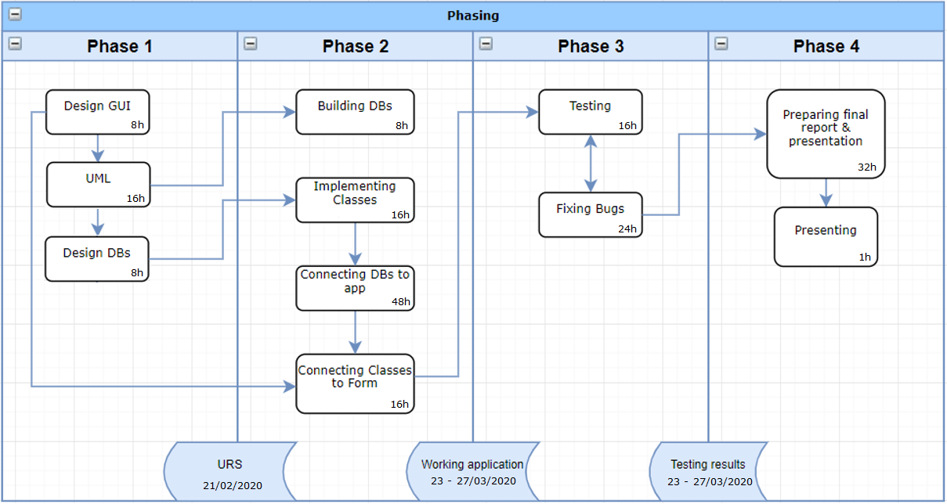

Figure 1. Workflow chart

A final presentation of the working solution to the customer and evaluation marks the end of the project part I.